CHOOSE EFFECTIVENESS
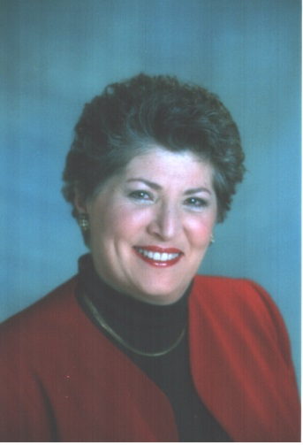
By Barbara Eldridge

Life gives us choices, we can either move up the ladder of success or we can hang on to the rungs and fail to move. Holding on is always safe and secure, while climbing is rough and uphill.  Most people in business are seeking greater success but often fail to follow through with the resources needed. The depth of real success is not a flash. It does not happen overnight and it is not always a matter of doing and having. There has to be time to grow; and effective business requires nothing less than personal effectiveness.  As you move forward in your quest for success work from the inside out. There are 7 key areas to be aware of that can help you fulfill your quest.  #BELIEF. First a belief in your own ability to succeed. With that belief there is a necessity to believe you are worthy of success. As you follow your plan and increase your productivity, you deserve recognition and happiness you experience. Your belief can expand to the realization that you also have a right to succeed.  #ATTITUDE. What is the predominant trait of a highly successful person? The right attitude!! Looking from the inside out is the one thing you have control over. It attracts people to you and is an awesome power for influencing those people.  #DECISION. Sometimes a decision is a realization that who you are, what you do and have is the result of a program that someone else wrote for you. Decision then is the choice to take action and "Do," to make the choices to "Have" what you want in your life and it is the choice of who and what you want to "Become" in fulfilling your own success. | #COMMITMENT. Once you make the decision to succeed, you must be willing to pay whatever price you have to pay to get it done. The automated modern world has made it easier for us to live in it; choices are much more diverse which create distractions and temptations. But, when you make a commitment to your goal and consistently make a conscious effort to follow your plan in spite of obstacles or criticism, you become ingrained with the habit of success. Then the physics principle takes over." A body in motion tends to stay in motion.  #FOCUS. In order to attract the success you want in your life you must stay focused to the specific results you want. Creating the focus means being clear about the details - visualization helps you practice and role-play so that you do and have what you want and can become, in handling your success.  #ACTION. The toughest word of all’ for it requires work. Without work, you lose the vision, confidence and determination to achieve. When you take action, you give credence to your belief in yourself and your success.  #ZEAL. This is an innate desire for self fulfillment of one’s own inner purpose. Zeal is desiring something so strongly that discouragement is unthinkable. Zeal is being so committed that you can persevere until every obstacle has been overcome and every problem solved.  So take out your ladder, test the steps and start climbing.

